NANABANYIN ESSEL SM/SMS/10/0026

22/10/2010 MED 111

EXPERIMENT 3 GROUP 7
DEFORMATION OF SOLID BODIES

AIM
To measure the deformation caused by the weight of mass pieces on two helical springs (3N/m and 20N/m).

APPARATUS
Support base with rod (600mm), double clamp, weight holder (10 g), pieces of slotted weights, two helical springs (3N/m and 20N/m), a holding pin, a glass tube holder and a measuring tape.

DIAGRAM
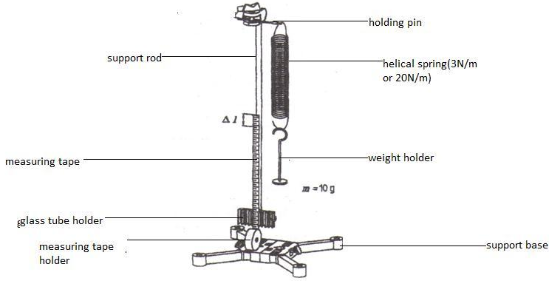

THEORY
HOOKE’s law states that provided the elastic limit of a body is not exceeded, the extension of an elastic body is proportional to the loads producing these extensions. In symbols, it implies F=k.∆l where F is the force produced by the load, k is the constant of proportionality(also known as the spring constant) and ∆l is the extension produced by the mass piece. If the spring is compressed or stretched a small distance from its equilibrium position, the spring will exert a force on the body given by the hooke’s law above. The springs constant is an indication of the spring’s stiffness. A large value for the spring constant indicate that the spring is stiff while a lower value for k indicates a soft spring. Generally, springs with large k can balance larger forces than one with small k. the value of k for a given spring is constant, but different for different springs. This means the force exerted by a spring is variable.

PROCEDURE
A stand was set up with the support base, the support rod and the double clamp. A holding pin was fixed in the double clamp and the helical spring (3N/m) was hanged on it. The glass tube holder was clamped to the base of the support rod and the measuring tape was clamped to it. The length of the measuring tape was extended so that the zero mark was exactly at the same level as the lower end of the helical spring. Then, the weight holder which has a mass of 10 g was hanged on the hooked end of the spring and the extension caused to the spring was recorded as ∆l. the mass was increased by 10 g increments to a total of 50 g and the corresponding extension in length ∆l was recorded each time.
Then the 3N/m spring was removed and the 20N/m helical spring was attached to the holding pin and again the zero mark on measuring tape was moved to the same level of the lower end of the helical spring. This time the 10 g weight holder plus a 10 g mass piece was hanged on thye hooked end of the spring and the extension was recorded as ∆l. then the mass was increased by increments of 20 g up to a total of 200 g and the corresponding extensions were recorded in length as ∆l.
All the values obtained were tabulated.

TABLE OF RESULT (observation)
1. Helical spring (3N/m)
Mass (M/g) | Weight(force) F_{g}/N | Deflection ∆l/cm
10.0 | 0.1 | 3.3
20.0 | 0.2 | 6.5
30.0 | 0.3 | 9.8
40.0 | 0.4 | 13.5
50.0 | 0.5 | 16.3

2. Helical spring (20N/m)
Mass M/g | Weight (force) F_{g}/N | Deflection ∆l/cm
20.0 | 0.2 | 1.0
40.0 | 0.4 | 2.0
60.0 | 0.6 | 3.0
80.0 | 0.8 | 4.0
100.0 | 1.0 | 5.0
120.0 | 1.2 | 6.0
140.0 | 1.4 | 7.0
160.0 | 1.6 | 8.0
180.0 | 1.8 | 9.0
200.0 | 2.0 | 9.9

GRAPH OF WEIGHT IN NEWTONS AGAINST DEFLECTION OF 3N/M HELICAL SPRING AND 20N/M HELICAL SPRING.

Equation of line 1

Gradient (∆l/F_{g})= ∆(∆l)/∆F_{g} =(15.0-9.0)/(0.5-0.3) = 30.0cm/N
Y=30X
Equation of line 2
Gradient (∆l/F_{g}) = ∆(∆l)/∆F_{g} = (8.0-4.0)/(1.6-O.8) = 5.0cm/N
Y=5X
8. a. k₁=∆l₁/F_{g1}; k₁=30.0cm/N
b. k₂=∆l₂/F_{g2}; k₂=5.0cm/N

DISCUSSION
3. They both indicate a positive gradient.
They both are in a straight line

4. From the graph, we can see that for line 1 there are large changes in deflection for small changes in the weight but from the line 2, there are small changes in deflection for increasing change in weight.
5. None were deformed by the weight as we can see from the graph, this is because the elastic limit was not reached for both experiments.
6. No, the values of the two spring lie on two different straight lines.
7. The graph indicates that the extension ∆l is directly proportional to the weight(force) F and thus to the mass.

Sources of Errors
-Reading of the extension could have presented an error since eye level could not be maintained at a perfect horizontal level to the measuring tape during the reading process.
-Measuring tape might have displaced during the experiment unknowingly producing slightly inaccurate readings.

Precautions
- The experiment was done several times over to produce an average reading.
- Changing of weights was done with care so as not to displace the measuring tape.

CONCLUSION
The measure of deformation has been produced and Hooke’s law has been verified. It has also been established that different springs have different spring constants.
Reference
-www.enotes.com
-P.A. Okyere, Practical Physics, 1990

